Email Template

- Subject Line:
  - Provide a clear and concise subject line for the email.
  - If you have a call to action, this is a place you can highlight it. I.e. Wisconsin Chapter Winter Event Registration Now Open
- Message Content:
  - Include the main body of the email. If there are specific points or details you want to highlight, please mention them.
  - If you have any links you’d like to run in your email, please include them.
For example:
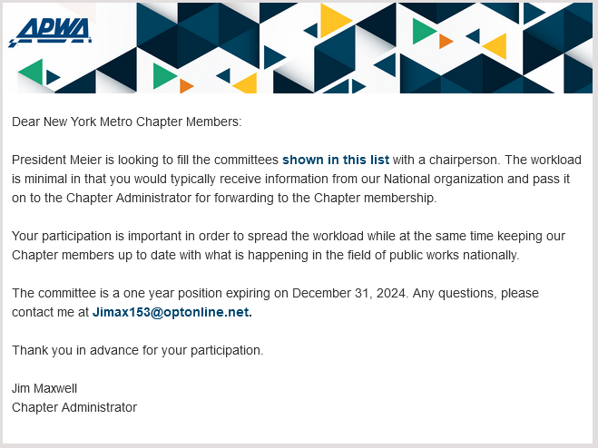
- Attachments:
  - If there are any attachments to be included in the email, please attach them to this email. If you are only sending out documents, please let us know what items you want highlighted so we can include that in a preview. For example:

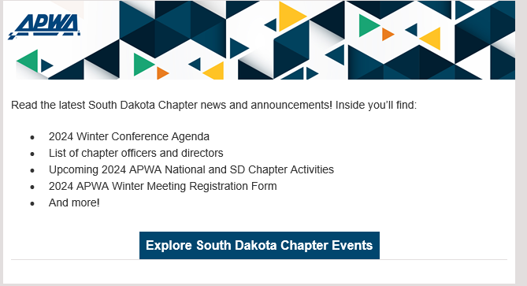

- Sending Date and Time:
  - Indicate the preferred date and time for sending the email. If time-sensitive, please mention any deadlines.
- Special Instructions:
  - Include any additional instructions or details that are crucial for the email.

